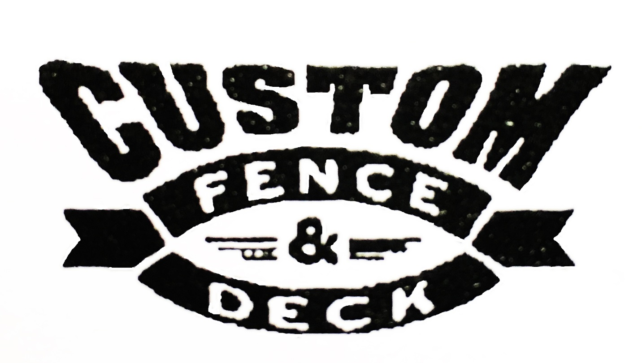
Wood, Vinyl, PVC & Ornamental
908-561-1482

